Software Requirements Specification

for

Online Boba Tea Ordering System: Shinju Brews



Version 1.0 approved

Prepared by:

Shubhika Verma (PES2UGG21CS517)

Surobhi Halder (PES2UGG21CS558)

Siddharth Rajendran (PES2UGG21CS524)

Shreyas Reddy (PES2UGG21CS508)

PES University

17th September 2023

Table of Contents

Table of Contents ii

Revision History ii

1. Introduction 1

1.1 Purpose

1.2 Intended Audience and Reading Suggestions

1.3 Product Scope

1.4 References

2. Overall Description 2

2.1 Product Perspective

2.2 Product Functions

2.3 User Classes and Characteristics

2.4 Operating Environment

2.5 Design and Implementation Constraints

2.6 Assumptions and Dependencies

3. External Interface Requirements 3

3.1 User Interfaces

3.2 Software Interfaces

3.3 Communications Interfaces

**4. Analysis Models**

5. System Features 4

5.1 System Feature 1

5.2 System Feature 2 (and so on)

6. Other Nonfunctional Requirements 4

6.1 Performance Requirements

6.2 Safety Requirements

6.3 Security Requirements

6.4 Software Quality Attributes

6.5 Business Rules

7. Other Requirements 5

Appendix A: Glossary 5

Appendix B: Field Layouts 5

Appendix C: Requirement Traceability matrix 6

# 

# Introduction

## Purpose

## *This Software Requirement Specification (SRS) defines the requirements for the development of the Online Boba Tea Ordering System for 'Shinju Brews,' version 1.0. It outlines the functional and non-functional requirements, intended audience, and product scope.*

## Intended Audience

## *This document is intended for developers, project managers, and other stakeholders involved in the development of the Online Boba Tea Ordering System. Readers are encouraged to refer to the references mentioned in this document for additional information.*

## Product Scope

The Online Boba Tea Ordering System is a web application that allows customers to browse, customize, and order boba tea products from nearby Shinju Brews outlets. It also provides an admin panel for system administrators to manage menu items, orders, and user accounts.

# Overall Description

## Product Perspective

The Online Boba Tea Ordering System is a self-contained product that serves as a platform for customers to order boba tea products and for administrators to manage the system. It is not part of a larger system and operates independently.

## Product Functions

The major functions of the system include:

* Menu exploration and customization for customers.
* Admin panel for system administrators to manage menu items, orders, and user accounts.

## User Classes and Characteristics

## *The system caters to the following user classes:*

## *Customers: Boba tea enthusiasts who place orders using the mobile application.*

## *Restaurant Partners: Partners running various restaurant outlets.*

## Operating Environment

The system will operate in a web-based environment. The hardware platform, operating system, and software components required will be specified during development.

## Design and Implementation Constraints

Constraints include:

* Compliance with corporate or regulatory policies.
* Hardware limitations and compatibility requirements.
* Use of specific technologies and tools.
* Security considerations and standards.

## 2.6 Assumptions and Dependencies

Assumptions include:

* Availability of third-party or commercial components.
* External policies or regulations affecting security and safety.
* Reuse of software components from other projects.

# External Interface Requirements

## User Interfaces

The system will have an intuitive user interface for customers and an admin panel for administrators. Detailed user interface specifications will be provided in separate documentation.

## 

## Software Interfaces

The system may interact with external software components, such as databases and payment gateways. Specific software interfaces and protocols will be defined during development.

## Communications Interfaces

The system may require communication with external services, including email, web browsers, and network servers. Communication protocols, data transfer rates, and security measures will be specified during development.

# Analysis Models

# 

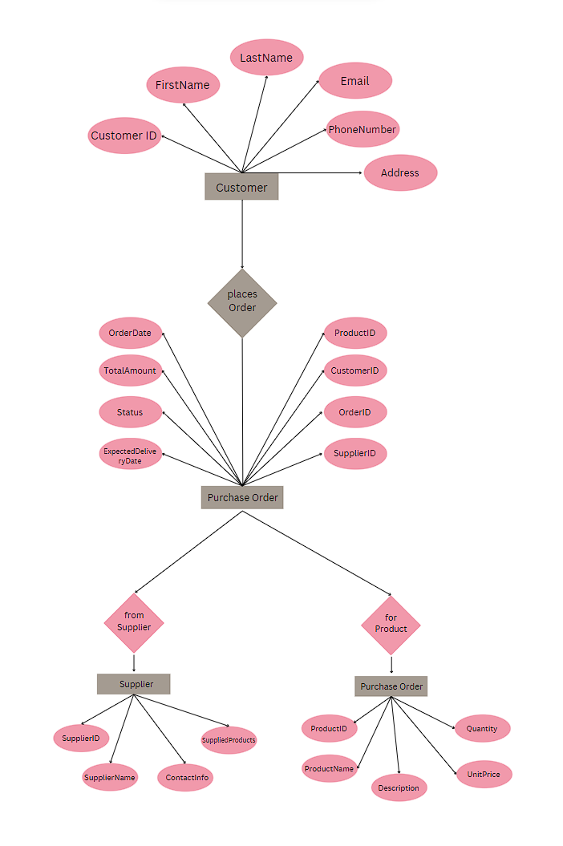

# System Features

## System Feature 1

Menu Exploration and Customization

5.1.1 Description and Priority

*Customers can browse the menu, view product descriptions and images, customize their orders, and add items to their cart. (Priority: High)*

5.1.2 Stimulus/Response Sequences

* Customer selects a menu item.
* System displays item details.
* Customer customizes the item.
* Customer adds the item to the cart.

5.1.3 Functional Requirements

## *REQ-1: Display menu items with descriptions and images.*

## *REQ-2: Allow customers to customize menu items.*

## *REQ-3: Add customized items to the cart.*

## System Feature 2

*Admin Panel Management*

5.1.1 Description and Priority

*System administrators can access an admin panel to manage menu items, view and process customer orders, and maintain user accounts. (Priority: High)*

5.1.2 Stimulus/Response Sequences

* Administrator logs into the admin panel.
* System displays the admin dashboard.
* Administrator selects menu management.
* System shows a list of menu items.
* Administrator edits or adds menu items.
* Administrator accesses the order management section.
* System displays a list of pending orders.
* Administrator processes orders (confirm, cancel, update status).
* Administrator accesses user account management.
* System provides user account details for administration.

5.1.3 Functional Requirements

* *REQ-4: Implement secure login for system administrators.*
* *REQ-5: Display an admin dashboard with menu, order, and user account* management *options.*
* *REQ-6: Allow administrators to add, edit, and delete menu items.*
* *REQ-7: Provide the ability to view and process customer orders.*
* *REQ-8: Allow order status updates (e.g., confirm, cancel).*
* *REQ-9: Enable user account management (create, modify, delete accounts).*
* *REQ-10: Implement access control to restrict unauthorized access to admin functions.*

## System Feature 3

*Order Management*

5.1.1 Description and Priority

*Customers can review and confirm their orders, select delivery or pickup options, make payments, and receive order confirmation. (Priority: High)*

5.1.2 Stimulus/Response Sequences

* Customer reviews the items in their cart.
* Customer selects delivery or pickup.
* Customer proceeds to checkout.
* System calculates the total order cost.
* Customer provides payment information.
* System generates an order confirmation.

5.1.3 Functional Requirements

## *REQ-11: Display the items in the customer's cart.*

## *REQ-12: Allow customers to choose between delivery and pickup.*

## *REQ-13: Calculate and display the total order cost.*

## *REQ-14: Integrate payment gateway for secure transactions.*

## *REQ-15: Generate and send order confirmation to the customer.*

# Other Nonfunctional Requirements

## Performance Requirements

The system must meet the following performance requirements:

* It should respond to user actions with minimal latency.
* It must handle a high volume of concurrent users during peak hours without degradation.

## Safety Requirements

## *The system must ensure the safety of user data and payment information. It should comply with safety certifications and regulations.*

## Security Requirements

The system must implement robust security measures to protect user data, including personal information and payment details. It should also adhere to security and privacy certifications.

## Software Quality Attributes

## *The system should exhibit the following software quality attributes:*

## *Usability: An intuitive and user-friendly interface.*

## *Reliability: Minimal downtime and backup mechanisms.*

## *Compatibility: Operability on popular web browsers.*

## Business Rules

* *Customer Registration*

*- Business Rule 1: Customers must provide a valid ISFC code during registration. Invalid ISFC codes will result in the rejection of the registration request.*

*- Business Rule 2: Customer names must not exceed 60 characters in length to ensure compatibility with the user interface.*

* *Order Placing*

*- Business Rule 3: Only registered customers with a minimum card balance of ₹50 can place orders. If the card balance is insufficient, the order placement will be declined.*

* *Admin Panel Access*

*- Business Rule 4: Access to the admin panel is restricted to authorized administrators with valid login credentials. Unauthorized access attempts will be logged and monitored.*

# Other Requirements

* *Database Requirements*

*The system shall use a PostgreSQL relational database management system (RDBMS) to store and manage customer profiles, menu items, orders, and transaction records.*

* *Internationalization Requirements*

*The user interface shall support English and Spanish languages to cater to a broader customer base.*

* *Legal and Compliance Requirements*

*The system shall comply with GDPR (General Data Protection Regulation) standards for data privacy, especially regarding the handling of customer information.*

* *Change Management*

*A change management process shall be established to track and manage changes to the system requirements, design, and code. This process shall include version control and documentation updates.*

* *Accessibility*

*The user interface shall adhere to WCAG (Web Content Accessibility Guidelines) Level AA standards to ensure accessibility for individuals with disabilities*

Appendix A: Glossary

<Define all the terms necessary to properly interpret the SRS, including acronyms and abbreviations. You may wish to build a separate glossary that spans multiple projects or the entire organization, and just include terms specific to a single project in each SRS.>

Appendix B: Requirement Traceability Matrix

|  |  |  |  |  |  |  |  |
| --- | --- | --- | --- | --- | --- | --- | --- |
| **Sl. No** | **Requirement ID** | **Brief Description of Requirement** | **Architecture Reference** | **Design Reference** | **Code File Reference** | **Test Case ID** | **System Test Case ID** |
| 1 | 01 | Display menu items | AR-001 | DR-001 | CR-001 | TC-001 | STC-001 |
| 2 | 02 | Add items to the cart | AR-002 | DR-002 | CR-002 | TC-002 | STC-002 |